PES UNIVERSITY
Department of Computer Science and Engineering

Software Requirements Specification
Simple-Shell (Command Line Interpreter)
Version 1.2
Prepared by: Diya (Team Lead), Debhargo, Aarush, Prithviraj
Group Number: [Fill Group Number]
Date Created: [Fill Date]

Revision History
Name | Date | Reason for Changes | Version
Diya, Debhargo, Aarush, Prithviraj | [Fill Date] | Initial draft of SRS | 1.0
Diya, Debhargo, Aarush, Prithviraj | [Fill Date] | Added use case diagram and Security Requirements section per Part-1 deliverable checklist | 1.1
Diya | [Fill Date] | Reassigned ownership of piping (REQ-16, REQ-17) to Debhargo and background execution (REQ-18, REQ-19) to Aarush to balance workload | 1.2

1. Introduction

1.1 Purpose
This document specifies the software requirements for Simple-Shell, a lightweight command-line interpreter (shell) written in C. It covers version 1.0 of the system in full — there is no larger system or subsystem of which this is a part.

1.2 Intended Audience
This SRS is intended for: the development team (Diya, Debhargo, Aarush, Prithviraj) implementing the shell; course instructors and evaluators assessing the project; and any future reader wanting to understand the system's requirements before extending it. The remainder of this document is organized into an overall description of the product, its external interfaces, a feature-by-feature breakdown of functional requirements, the non-functional requirements and constraints that apply across the system, and a dedicated section on security requirements.

1.3 Product Scope
Simple-Shell is a standalone, self-contained command-line application. It does not depend on or extend any existing shell implementation — it is built from scratch in C using standard POSIX system calls. Its scope covers reading user input, interpreting it, executing commands (built-in or external), and returning output to the user in a continuous loop. The project's purpose is primarily educational: it demonstrates, in a hands-on way, the fundamental mechanics of process creation, command parsing, and I/O handling that underlie all Unix-like shells.

1.4 References
- Project Guidelines document (course-provided), defining proposal and submission requirements.
- SRS Document/Template (course-provided), defining the structure this document follows.
- SE Mini-Project Deliverables Part-1 (course-provided), defining the IEEE-format checklist this revision satisfies.
- POSIX.1 system interface documentation, for fork(), exec(), wait(), pipe(), dup2(), and related calls.
- Project README (team repository), describing build instructions and usage.

2. Overall Description

2.1 Product Perspective
Simple-Shell is a new, self-contained product — it is not a follow-on to an existing system and does not replace any existing software. It is one of the course's assigned sample software projects rather than a team-proposed idea. The system has no external subsystems it must interface with beyond the host operating system's kernel (via POSIX system calls) and the file system.

2.2 Product Functions
At a high level, the system allows a user to:
- Launch the shell and interact with it through a continuous prompt (REPL).
- Run any standard external command available on the system (e.g., ls, cat, grep).
- Use built-in commands such as cd, exit, pwd, and echo.
- Redirect a command's input or output to/from a file using <, >, and >>.
- Chain multiple commands together using pipes (|).
- Run commands in the background using &.
- Receive clear error messages for invalid commands, missing files, or malformed input, without the shell crashing.

2.3 User Classes and Characteristics
User Class | Description | Importance
Command-line end users | People comfortable in a terminal who want to run everyday shell commands: navigation, running programs, redirection, piping. | Most important
Evaluators / students | Course instructors grading the project, and anyone studying how a shell is implemented internally. | Important

2.4 Operating Environment
- Any POSIX-compliant operating system (Linux or macOS); on Windows, via WSL2 or an equivalent Linux environment.
- A standard terminal / text console — no GUI component.
- GCC or any C99-compatible compiler, plus make.

2.5 Design and Implementation Constraints
- Must be implemented in C, using standard POSIX system calls (fork, exec, pipe, dup2, wait, etc.).
- No reliance on third-party shell libraries — core logic must be implemented directly by the team.
- Must run in a standard terminal environment; no GUI is in scope.
- Code must be modular — parsing, execution, built-ins, and redirection/piping are kept in separate source files.

2.6 Assumptions and Dependencies
- It is assumed the development and test machines provide a POSIX-compliant environment with a standard C library.
- It is assumed standard external utilities (ls, cat, grep, etc.) are present on the test machine's PATH for functional testing.
- The project depends only on the standard C library and POSIX APIs — no external/third-party libraries are planned.

3. External Interface Requirements

3.1 User Interfaces
The only interface is a text-based command-line prompt (e.g., myshell> ). Input is read from standard input; normal output is written to standard output; error messages are written to standard error, prefixed clearly enough for the user to identify the cause (e.g., invalid command, missing file, permission denied).

3.2 Software Interfaces
The shell interfaces with the host operating system kernel through POSIX system calls, namely fork(), execve()/execvp(), wait()/waitpid(), pipe(), dup2(), and standard file I/O calls (open(), read(), write(), close()). It interfaces with external executables resolved via the PATH environment variable, and with the file system for any redirection targets the user specifies.

3.3 Communications Interfaces
None. Simple-Shell is a standalone local process and has no network communication requirements.

4. Analysis Models
The system follows a simple linear data flow for each command line entered by the user:
User input → Parser (tokenization) → Executor (built-in dispatch or fork/exec) → Redirection / Piping layer → Output to terminal or file
Each stage's output is the next stage's input, which is why the team has agreed on shared data structures (e.g., a parsed-command representation) up front, allowing each module to be developed and unit-tested independently before integration.

4.1 Use Case Diagram
The diagram below identifies the primary actor (the end user) and the main use cases the system supports.
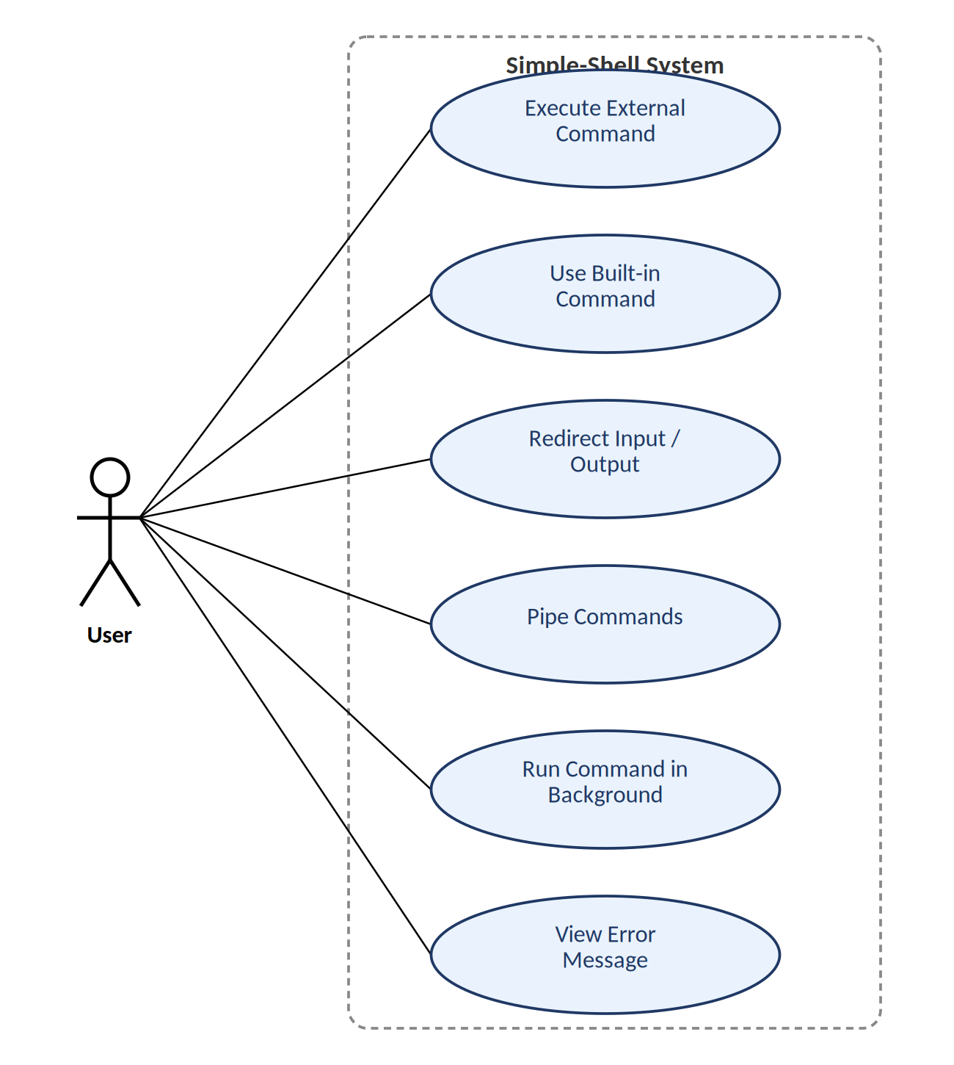

5. System Features
Each functional requirement below is written as a single, verifiable “shall” statement to keep requirements clear, unambiguous, concise, and measurable, per the course's specification guidelines.

5.1 REPL Loop and Built-in Commands
Owner: Prithviraj

5.1.1 Description and Priority
Provides the shell's main interactive loop and the small set of commands that must execute within the shell's own process rather than as a child process. Priority: High — without this, the shell cannot run at all.

5.1.2 Stimulus/Response Sequences
The user types a command and presses Enter. The shell reads the line, and either dispatches it to a built-in handler (if it matches cd, exit, pwd, echo, or help) or passes it on to the execution engine. On exit or EOF (Ctrl+D), the loop terminates and the shell exits cleanly.

5.1.3 Functional Requirements
REQ-1: The system shall display a prompt and read a line of input from the user within 100ms of the previous command completing.
REQ-2: The system shall loop continuously, accepting new commands, until the user issues the exit command or sends EOF (Ctrl+D).
REQ-3: The system shall support the built-in commands cd, exit, pwd, echo, and help, executed within the shell's own process.
REQ-4: If cd is given a non-existent or inaccessible directory, the system shall print a single-line error message and remain in the current working directory.

5.2 Command Parsing / Tokenization
Owner: Aarush

5.2.1 Description and Priority
Converts a raw input line into a structured command (a command name plus its arguments) that the execution engine can consume. Priority: High — every other feature depends on correctly parsed input.

5.2.2 Stimulus/Response Sequences
A raw input line is received from the REPL. The parser splits it into tokens, resolves quoted substrings into single arguments, and identifies special operators (<, >, >>, |, &) as structural delimiters rather than literal arguments. The resulting structured command is handed to the executor or redirection/piping layer.

5.2.3 Functional Requirements
REQ-5: The system shall split input into a command and its arguments, correctly handling any number of consecutive whitespace characters.
REQ-6: The system shall treat text enclosed in single or double quotes as exactly one argument, including any embedded spaces.
REQ-7: The system shall recognize <, >, >>, |, and & as structural operators distinct from ordinary command arguments.
REQ-8: The system shall handle empty or whitespace-only input lines without error, simply re-displaying the prompt.

5.3 Command Execution
Owner: Debhargo

5.3.1 Description and Priority
Runs external (non-built-in) programs and reports their outcome back to the shell. Priority: High — this is the core capability that makes the system a usable shell.

5.3.2 Stimulus/Response Sequences
A structured, non-built-in command is received from the parser. The executor forks a child process, resolves and executes the target program in the child, and the parent waits for completion (unless the command is flagged for background execution), then reports the exit status.

5.3.3 Functional Requirements
REQ-9: The system shall execute external commands using fork() and a member of the exec() family of system calls.
REQ-10: The system shall resolve the executable's location using the PATH environment variable when a bare command name is given.
REQ-11: The parent process shall wait() for the child process to complete before returning control to the prompt, unless the command is running in the background.
REQ-12: If the command cannot be found or is not executable, the system shall print a single-line error message within 1 second and return to the prompt without crashing.

5.4 I/O Redirection
Owner: Diya

5.4.1 Description and Priority
Allows a command's standard input or output to be redirected to/from a file instead of the terminal. Priority: Medium.

5.4.2 Stimulus/Response Sequences
The parser identifies a <, >, or >> operator and an associated filename. Before executing the command, the redirection layer opens the target file with the appropriate flags and uses dup2() to replace the relevant standard file descriptor.

5.4.3 Functional Requirements
REQ-13: The system shall redirect standard input from a file when < filename is specified.
REQ-14: The system shall redirect standard output to a file, overwriting its contents, when > filename is specified.
REQ-15: The system shall redirect standard output to a file, appending to its contents, when >> filename is specified.

5.5 Piping
Owner: Debhargo

5.5.1 Description and Priority
Allows two or more commands to be chained so that one command's output becomes the next command's input. Priority: Medium.

5.5.2 Stimulus/Response Sequences
The parser splits the input on | into a sequence of commands. The piping layer creates a pipe() between each adjacent pair, forks a process for each command, wires standard output/input through the pipe via dup2(), and closes unused file descriptors in every process.

5.5.3 Functional Requirements
REQ-16: The system shall support chaining two or more commands with | such that the standard output of each command becomes the standard input of the next.
REQ-17: The system shall close all unused pipe file descriptors in both parent and child processes immediately after the relevant dup2() call.

5.6 Background Execution and Environment Handling
Owner: Aarush (background execution, REQ-18–REQ-19), Diya (environment/PATH handling, REQ-20)

5.6.1 Description and Priority
Allows commands to run without blocking the prompt, and makes environment variables available to child processes. Priority: Medium.

5.6.2 Stimulus/Response Sequences
If the input line ends with &, the shell forks the command as usual but the parent does not wait for it, instead recording its process ID and immediately redisplaying the prompt.

5.6.3 Functional Requirements
REQ-18: The system shall execute a command in the background, without waiting for it, when the command line ends with &, and shall redisplay the prompt within 100ms.
REQ-19: The system shall maintain a list of background job IDs and process IDs for the current session, viewable on request.
REQ-20: The system shall make environment variables available to child processes and support reading of variables such as PATH and HOME.

5.7 Command History and Signal Handling (Stretch Goals)
Owner: Shared

5.7.1 Description and Priority
Optional quality-of-life features to be attempted only after all core features (5.1–5.6) are complete and tested. Priority: Low.

5.7.2 Stimulus/Response Sequences
The shell records each accepted command line for recall; on receiving SIGINT (Ctrl+C) or SIGTSTP (Ctrl+Z), the shell intercepts the signal and responds without terminating unexpectedly.

5.7.3 Functional Requirements
REQ-21: The system should maintain a history of at least the last 50 commands entered in the current session.
REQ-22: The system should handle SIGINT (Ctrl+C) by returning to a fresh prompt rather than terminating the shell.
REQ-23: The system should handle SIGTSTP (Ctrl+Z) by suspending the current foreground job, if one is running.

6. Other Nonfunctional Requirements

6.1 Performance Requirements
Built-in commands shall return control to the prompt within 100ms under normal load, since no external process needs to be spawned for them.

6.2 Safety Requirements
Not applicable in the physical sense. The closest equivalent: the shell must not modify or delete any file the user did not explicitly target (e.g., via redirection), and must not leave orphaned or zombie child processes behind after it exits.

6.3 Security Requirements
See Section 8 (Security Requirements) for the dedicated security objectives and requirements.

6.4 Software Quality Attributes
- Reliability — the shell must not crash or hang on invalid input, missing files, or failed system calls; it prints a clear error and returns to the prompt.
- Portability — the shell shall compile and run on any POSIX-compliant system (Linux/macOS) without modification.
- Usability — error messages shall be clear enough for a user to understand what went wrong and how to correct it.
- Maintainability — code shall be modular (separate parsing, execution, redirection, built-ins) so features can be extended independently.

6.5 Business Rules
Not applicable in the commercial sense, as this is an academic coursework project with no end customer. The closest equivalent operating principle is the team's own module ownership: each functional feature has one clearly accountable owner (see Appendix C), though all members review and test across the whole system.

7. Other Requirements
- The project shall be organized into separate source files per module (main.c, parser.c, executor.c, builtins.c, redirection.c) as described in the project README.
- The project shall build with a single make command via a provided Makefile, producing an executable named myshell.
- No internationalization, database, or licensing requirements apply to this coursework project.

8. Security Requirements

8.1 Security Objectives
- Confinement: the shell shall never grant a user or spawned process capabilities beyond what the invoking user's own OS account already permits (no privilege escalation).
- Integrity of unrelated data: the shell shall never read, write, or delete files other than those the user explicitly names (as a command argument or a redirection target).
- Fail-safe behaviour: on any unexpected, malformed, or malicious input, the shell shall degrade to a clear error message rather than crashing, hanging, or executing unintended actions.

8.2 Security Requirements
REQ-SEC-1: The system shall execute all commands with the same user and group privileges as the invoking shell process; it shall not use setuid/setgid or any mechanism that elevates privileges.
REQ-SEC-2: The system shall validate and canonicalize every redirection file path before calling open(), rejecting paths containing unresolved parent-directory traversal (..) outside the user's intent without at least an explicit confirmation path in future iterations.
REQ-SEC-3: The system shall not print or log the value of environment variables except when the user explicitly requests it (e.g., via an echo of that variable).
REQ-SEC-4: The system shall impose a maximum input line length (e.g., 4096 characters) and a maximum argument count per command, rejecting longer input with a clear error, to prevent unbounded buffer growth.
A fuller threat-modeling treatment (STRIDE) is provided in the companion Software Architecture & Design Specification, Section 3.9.

Appendix A: Glossary
- REPL — Read-Eval-Print Loop; the shell's main interactive cycle of reading, interpreting, and executing input.
- fork() — POSIX system call that creates a new child process, duplicating the calling process.
- exec() family — POSIX system calls that replace a process's memory image with a new program.
- wait() / waitpid() — POSIX system calls that block the calling process until a child process changes state (e.g., terminates).
- PATH — an environment variable listing directories the shell searches for executables.
- Pipe — a unidirectional communication channel between two processes, created with pipe() and connected via dup2().
- Redirection — changing a command's standard input or output from the terminal to a file, using <, >, or >>.
- Built-in command — a command executed directly within the shell's own process rather than via fork/exec (e.g., cd).
- Zombie process — a terminated child process whose exit status has not yet been collected by its parent via wait().
- Background job — a command launched with & that runs without blocking the shell's prompt.
- SIGINT / SIGTSTP — POSIX signals triggered by Ctrl+C and Ctrl+Z respectively.
- STRIDE — a threat-modeling framework (Spoofing, Tampering, Repudiation, Information disclosure, Denial of service, Elevation of privilege).

Appendix B: Command Syntax Reference
In place of a data field layout (not applicable to a command-line tool with no persistent data store), this appendix lists the shell's recognized operators and syntax, which function as this project's closest equivalent to an interface field reference.
Operator | Meaning | Example
< | Redirect standard input from a file | sort < names.txt
> | Redirect standard output to a file (overwrite) | echo hi > out.txt
>> | Redirect standard output to a file (append) | echo hi >> out.txt
| | Pipe output of one command into the next | cat out.txt | grep hi
& | Run the preceding command in the background | sleep 10 &
" " | Treat enclosed text (incl. spaces) as one argument | echo "Hello World"

Appendix C: Requirement Traceability Matrix
Code File Reference, Test Case ID, and System Test Case ID columns are to be filled in as implementation and testing proceed. See the companion Software Test Plan for the full requirement-to-test-case mapping.
REQ-ID | Owner | Brief Description | Code File Reference
REQ-1 | Prithviraj | Display a prompt and read a line of input
REQ-2 | Prithviraj | Loop continuously until exit / EOF
REQ-3 | Prithviraj | Support built-in commands (cd, exit, pwd, echo, help)
REQ-4 | Prithviraj | Handle invalid cd target gracefully
REQ-5 | Aarush | Split input into command + arguments, handle whitespace
REQ-6 | Aarush | Support quoted strings as single arguments
REQ-7 | Aarush | Recognize <, >, >>, |, & as delimiters
REQ-8 | Aarush | Handle empty input lines without error
REQ-9 | Debhargo | Execute external commands via fork()/exec()
REQ-10 | Debhargo | Resolve executable path via PATH
REQ-11 | Debhargo | Parent waits for child unless backgrounded
REQ-12 | Debhargo | Report clear error for missing/non-executable command
REQ-13 | Diya | Redirect stdin from a file (<)
REQ-14 | Diya | Redirect stdout to a file, overwrite (>)
REQ-15 | Diya | Redirect stdout to a file, append (>>)
REQ-16 | Debhargo | Chain commands with pipes (|)
REQ-17 | Debhargo | Close unused pipe file descriptors correctly
REQ-18 | Aarush | Run a command in the background (&)
REQ-19 | Aarush | Maintain a basic background job list
REQ-20 | Diya | Expose environment variables to child processes
REQ-21 | Shared | (Stretch) Maintain command history
REQ-22 | Shared | (Stretch) Handle SIGINT (Ctrl+C)
REQ-23 | Shared | (Stretch) Handle SIGTSTP (Ctrl+Z)
REQ-SEC-1 | Diya | Shell shall not escalate privileges beyond invoking user
REQ-SEC-2 | Diya | Shell shall sanitize/validate redirection file paths before opening
REQ-SEC-3 | Diya | Shell shall not log or expose environment variable values beyond what the user explicitly requests

